A
Project Report
On
Architecture Visualization
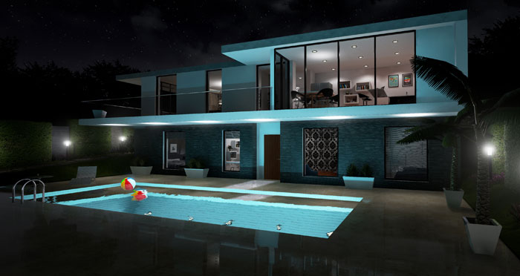

Prepared by
14CE050 Apexa Kansara
14CE054 Vivek Majithia
14CE059 Agadh Mankad
Under the guidance of
Prof. Hardik Mandora

Submitted to
Charotar University of Science & Technology
Degree of Bachelor of Technology
in Computer Engineering
CE324-Software Group Project
Of 6th Semester of B.Tech
Submitted at

U. & P. U PATEL DEPARTMENT OF COMPUTER ENGINEERING
Faculty of Technology & Engineering, CHARUSAT
Chandubhai S. Patel Institute of Technology
At: Changa, Dist: Anand – 388421
January-June 2017

CERTIFICATE

This is to certify that the report entitled “Architecture Visualization” is a bonafied work carried out by Ms. Apexa Kansara (14CE050), Mr. Vivek Majithia (14CE054) & Mr.Agadh Mankad(14CE059) under the guidance and supervision of Prof. Hardik Mandora for the subject Software Group Project (CE324) of 6th Semester of Bachelor of Technology in Computer Engineering at Faculty of Technology & Engineering (C.S.P.I.T.) – CHARUSAT, Gujarat.

To the best of my knowledge and belief, this work embodies the work of candidate himself, has duly been completed, and fulfills the requirement of the ordinance relating to the B.Tech. Degree of the University and is up to the standard in respect of content, presentation and language for being referred to the examiner.

Under the supervision of,

Prof. Hardik Mandora
Assistant Professor,
U. & P. U Patel Dept. of Computer Engg.
C.S.P.I.T., CHARUSAT-Changa.
Dr. (Prof.) Amit Ganatra
Dean,
Faculty of Technology & Engineering
Head, U. & P. U Patel Department of Computer Engineering
C.S.P.I.T., CHARUSAT- Changa, Gujarat.

Chandubhai S Patel Institute of Technology (C.S.P.I.T.)
Faculty of Technology & Engineering, CHARUSAT
At: Changa, Ta. Petlad, Dist. Anand, PIN: 388 421. Gujarat

Abstract

This project “Architecture Visualization” is purely developed on the basis of virtual reality with the help of unity and blender software. This Application is purely second perspective with medium GUI. This application support Unity 5.5.1f1 (64-bit) or higher only. Every person can use application2 . It is use for security purpose, private defectivities, laptop login etc.

Acknowledgement

I am thankful to our HOD Prof. Amit Ganatra and internal guide Prof. Hardik Mandora from Charusat for her guidance and constant supervision as well as for providing necessary information at each and every stage of the project. I would like to thank all my family members and friends for their support in developing the project and the people who have willing helped me out with their abilities.

Table of contents

Abstract i
Acknowledgement ii
Chapter1 Introduction 1
1.1. Purpose 1
1.2. Scope 1
1.3. Definitions, acronyms & abbreviations 1
1.4. References 1
1.5. Overview 2

Chapter 2 Overall description 3
2.1. Product perspective 3
2.1.1. System interfaces 3
2.1.2. User interfaces 3
2.1.3. Hardware interfaces 3
2.1.4. Software interfaces 3
2.1.5. Communications interfaces 3
2.1.7. Operations 3
2.1.8. Site adaptation requirements 3
2.2. Product functions 4
2.3. User characteristics 4
2.4. Constraints 4

Chapter 3 System Analysis 5
3.1 Requirements of New System 5
3.1.1 Functional Requirements 5
3.1.2 Non Functional Requirements 5
3.2 Feasibility Study 5
3.2.1 Does the system contribute to the overall objectives of the
organization? 5
3.2.2 Can the system be implemented using current technology and
within the given cost and schedule constraints? 5
3.2.3 Can the system be integrated with other system already in
place? 5
3.3 System Activity (Use case and/or scenario diagram) 6
3.4 Class Diagram 7
3.5 Sequence Diagram 8
3.6 Functions of system 8
3.7 Context Diagram 9
3.8 Data Flow Diagram (0 and 1 level or higher) 10
3.9Selection of Hardware and Software and Justification 11
Chapter 4 Project estimation ……….................................................................................12
  - Estimation technique used ………………………..........................................12
  - Effort resource, cost, project duration estimation ...........................................12

Chapter 5 Schedule in which ……………........................................................................15
  - breakdown structure ………...........................................................................15
  - Task network representation .........................................................................16
  - Gantt chart representation ..............................................................................16
  - Pert chart representation ................................................................................17
.
Chapter 6 Project resources .............................................................................................. 18
  - People ..............................................................................................................18
  - Hardware & Software ..................................................................................... 18
  - Special resources .............................................................................................18

Chapter 7 Project tracking & control plan .........................................................................19

Chapter 8 System Design ..................................................................................................20
8.1 System Application Design .............................................................................20
    - Method Pseudo code .....................................................................20
    - Samples Of Forms, Reports and Interface ....................................20

Chapter 9 Implementation Planning .................................................................................22
a. Implementation Environment (Single vs Multiuser, GUI vs Non GUI)...22
  - Program/Modules Specification(refer appendix C) 24 Security Features………………………………………………………………......22
  - Coding Standards ......................................................................................22

Chapter 10 Testing ............................................................................................................23
- Testing Plan ..............................................................................................23
- Testing Strategy ....................................................................................... 23
- Testing Methods .......................................................................................23
- Test Suites Design ....................................................................................23
- Test Cases ................................................................................................ 23
    - Purpose .............................................................................23
    - Required Input ..................................................................23
    - Expected Result ................................................................23

Chapter 11 Limitation and Future Enhancement .............................................................25

Chapter 12 Conclusion and Discussion ...........................................................................26
- Self Analysis of Project Viabilities ............................................................... 26
- Problem Encountered and Possible Solutions ...............................................26
- Summary of Project work ..............................................................................26

CHAPTER 1: INTRODUCTION

1.1. PURPOSE:
- It will be useful in such type of applications where face detection and recognition.
- It is helpful to detect the face and capturing the photo at that moment.

1.2. SCOPE:

- Face detection system is designed to provide different standard face database consisting a range of different face images varying in facial expression, lightening effect, presence and absence of accessories.

1.3. DEFINITIONS, ACRONYMS AND ABBREVIATION:

- CV- Computer Vision
- UI- User Interface
- FD- Face Detection
- GUI- Graphical User Interface

1.4. REFERENCES:
The books and materials referred during the pre-development stages of the project include:
- https://www.youtube.com/watch?v=Z78zbnLlPUA&list=PLQVvvaa0QuDdttJXlLtAJxJetJcqmqlQq
- http://opencv.org/
- http://www.tutorialspoint.com/python/
- https://www.python.org/about/gettingstarted/

1.5. OVERVIEW:

- Face recognition systems used today work very well under constrained conditions, although all systems work much better with frontal mug-shot images and constant lighting.
- All current face recognition algorithms fail under the vastly varying conditions under which humans need to and are able to identify other people.
- Next generation person recognition systems will need to recognize people in real-time and in much less constrained situations.

CHAPTER 2 OVERALL DESCRIPTION:

2.1. PRODUCT PERSPECTIVE:
- First we open the application of face detection then it will show your camera images from that it will recognize your face and capture two images sequentially.
- First image is your full image and second one is only of your capurise face.

2.1.1. System Interfaces:
- An interface is a shared boundary across which two separate components of a computer system exchange information.
- List each system interface and identify the functionality of the software to accomplish the system requirement and the interface description to match the system. These are external systems that you have to interact with. For instance, if you are made face recognition application that interfaces with the existing with user.
- It’s prepare in opencv software with python in the laptop.
- System take few second open the webcam in application.

2.1.2: User Interfaces:
  - A user interface is a point of interaction between a computer and humans; it includes any number of modalities of interaction where data is transferred between the user and application.
  - User select application in laptop and start the application.

2.1.3: Hardware interfaces:
- Hardware interfaces exist in many of the components such as the various buses, storage devices, other I/O devices, etc. A hardware interface is described by the mechanical, electrical and logical signals at the interface and the protocol for sequencing them. A standard interface, such as design and introduction of computing hardware, such as I/O devices, from the design and introduction of other components of a computing system, thereby allowing users and manufacturers great flexibility in the implementation of computing systems.
- Hardware interfaces can be parallel with several electrical connections carrying parts of the data simultaneously, or serial where data is sent one bit at a time.

2.1.4: Software Interfaces:

NAME | VERSION | SOURCE
Unity | 5.5.1f1 (64-bit) | VR
blender | 2.78 | VR

2.1.5: Communication Interface:
- An interface in the work environment is used for a point of interaction between a number of systems or work groups. In the manufacturing environment, the coordination and interaction between several work groups is used to communicate plans and control production activity.
- This interaction can be schedules, human interactions, computer systems, or any other medium of communication.

2.1.6: Memory Constraints:
- In modern personal computers, some limits are due to the design of processor, others due to the design of chipsets, BIOS and other hardware and related electrical limitations.
- Operating system and application software on a hardware platform may not have the capacity to use the full address space physically available.

2.1.7: Operations:
- It has anytime, anywhere to capture particular face, detect it and save it on current folder.

2.1.8: Site Adaptation Requirements:
- The software requires no special modifications to adapt to particular installations.

2.2. PRODUCT FUNCTIONS:
- The major function includes:
- Detection of face.
- Detection of eyes.
- Save the capturize face in current folder.

  - USER CHARACTERISTICS:
- It is sufficient that the users have a basic knowledge of using IDLE python GUI.

2.4. CONSTRAINTS:
- System need certain amount of light and cleared image of face to recognize it properly.

CHAPTER 3 SYSTEM ANALYSIS:

3.1 REQUIREMENTS OF NEW SYSTEM

    - Functional Requirements
- It will give the well captured face of particular user of the system.
- User get saved detected face of himself.
- It is giving users three recognized pictures prospectively whole image of user, only detected face and only captured eyes.
3.1.2 Non Functional Requirements
- Better GUI.
- Better Performance.

3.2 FEASIBILITY STUDY

3.2.1 Does the system contribute to the overall objectives of the
Organization?
Yes, the system developed contributes to all objects.

3.2.2 Can the system be implemented using the current technology and
Within the given cost and schedule constraints?
Yes, the system can be implemented using python, face detection and recognition technique and xml file
3.2.3 Can the system be integrated with other system which are already in
Place?
Yes, the system can be integrated with other systems.

3.3 SYSTEM ACTIVITY
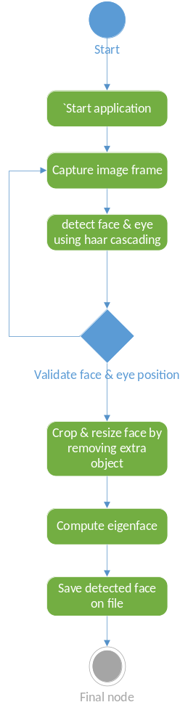

3.4 CLASS DIAGRAM

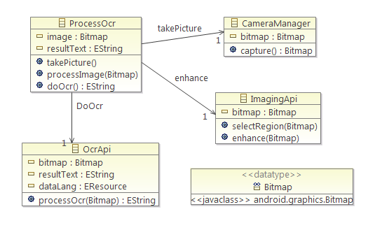

3.5 SEQUENCE DIAGRAM

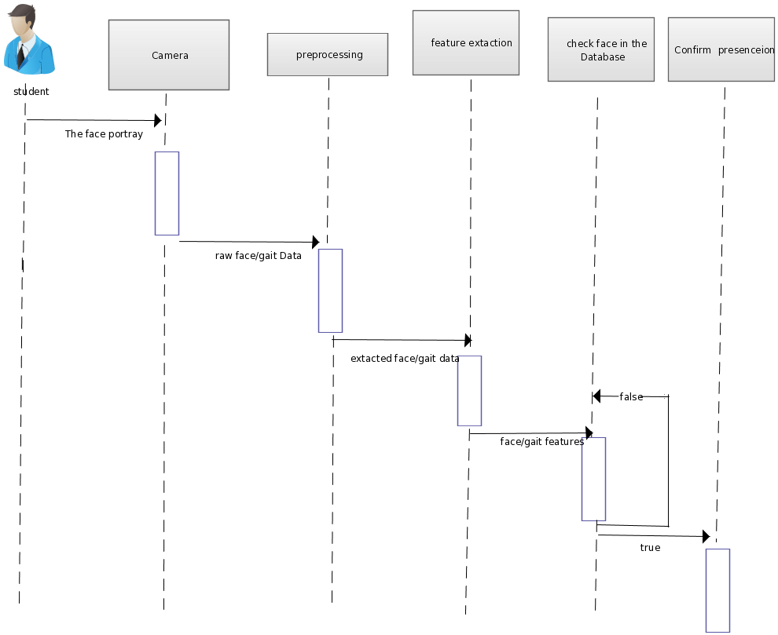

  - FUNCTIONS OF SYSTEM

- Capture the image frame using webcam.
- Detect the face and eye from the image frame.
- If it is valid then recognized face and whole image is stored into the current folder.

  - CONTEXT DIAGRAM

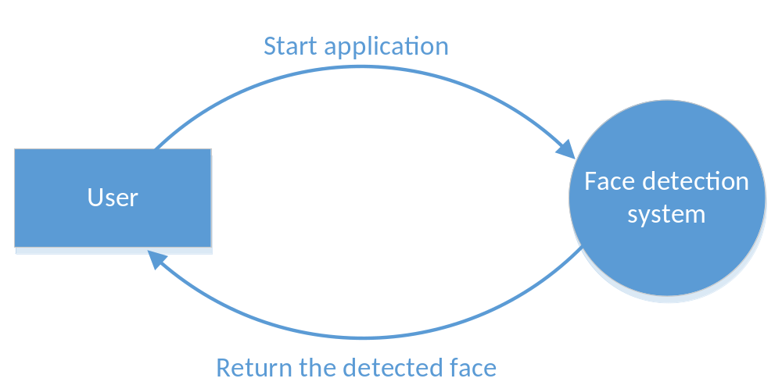

3.8 DATA FLOW DIAGRAM

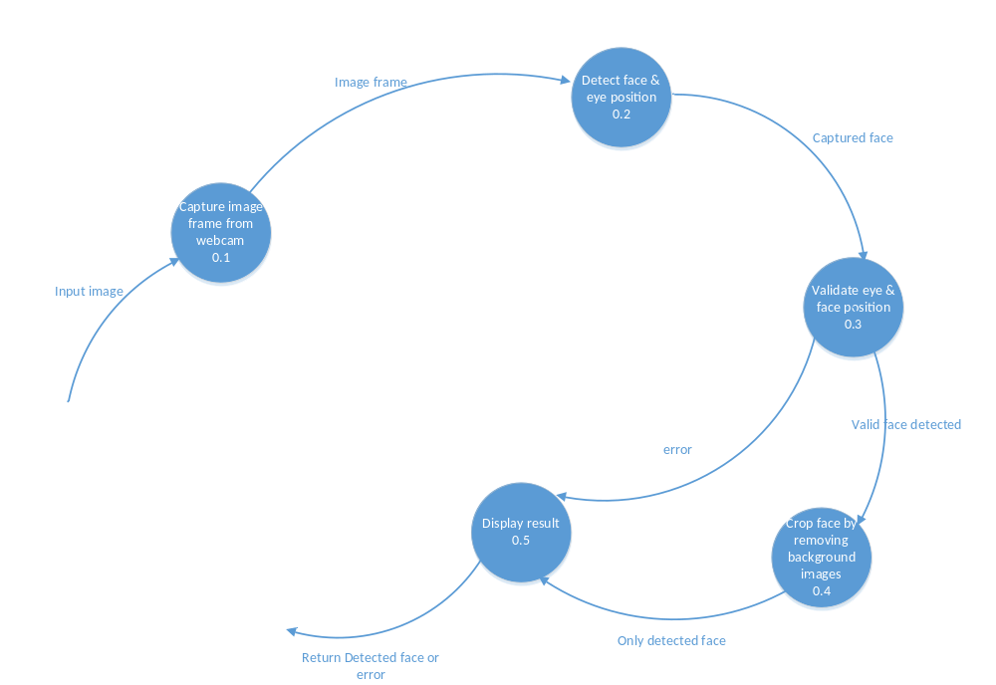

3.9 SELECTION OF HARDWARE AND SOFTWARE AND
JUSTIFICATION

- We have selected IDLE python editor, OpenCV in python. Using these software, we can implement the project and give all the functionalities.

CHAPTER 4 : PROJECT ESTIMATION

4.1 ESTIMATION TECHNIQUE USED:

  - EFFORT RESOURCE, PROJECT DURATION ESTIMATION:

Parameters | Count |  | Simple | Average | Complex |  | Total
No. of user Input | 5 | X | 3 | 4 | 6 | = | 20
No. of user Output | 5 | X | 4 | 5 | 7 | = | 25
No. of Inquires | 1 | X | 3 | 4 | 6 | = | 3
No. of Files | 7 | X | 7 | 10 | 15 | = | 49
external Interface | 1 | X | 5 | 7 | 10 | = | 7

Complexity Weight Factor:
Sr. No. | Factors | Weights
1. | Does the system require reliable backup and recovery? | 2
2. | Are data communication required? | 2
3. | Are there distributed processing functions? | 0
4. | Is performance critical? | 0
5. | Will the system run in an existing, heavily utilized operational environment? | 2
6. | Does the system require online data entry? | 0
7. | Does the on-line data entry require the input transactions to be built over multiple screens or operation? | 0
8. | Are the master file updated on-line | 1
9. | Are the inputs, outputs, files, or inquiries complex? | 2
10. | Is the internal processing complex? | 2
11. | Is the code designed to be reusable? | 3
12. | Are conversion and installation included in the design? | 0
13. | Is the system designed for multiple installations in different organizations? | 2
14. | Is the application designed to facilitate change and ease of use by the user? | 3

Weight | Degree Of Influence
0 | No Influence
1 | Incidental
2 | Moderate
3 | Average
4 | Significant
5 | Essential

FP Count:
FP = count total*[0.65+0.01 *∑(Di)]
FP = 126* [0.65+0.01*19]
Function Point is: 27.05
Line of code (LOC) = FP*3 =FP *3= 91
KLOC =0.91

Software Project Type
Type | a_{b} | b_{b} | c_{b} | d_{b}
Organic | 2.4 | 1.05 | 2.5 | 0.38
Semi-detached | 3.0 | 1.12 | 2.5 | 0.35
Embedded | 3.6 | 1.20 | 2.5 | 0.32

Effort = a_{b}*(KLOC) ^b_{b}
= 3.0*(0.91) ^1.12
= 8.49 PM
Tdev = c_{b} * (Effort) ^d_{b}
= 2.5*(8.49) ^0.35
=4.78 Months
CHAPTER 5: SCHEDULE IN WHICH

  - BREAKDOWN STRUCTURE

Architecture Visualization

Requirement
Gathering

Project
Development

Requirement
Analysis

Requirement
Specification

Design

Testing

Implementation

Documentation
UI
Design
Implementation of modules

Unit
Testing

System
Testing

Integration
Testing

5.2 TASK NETWORK REPRESENTATION

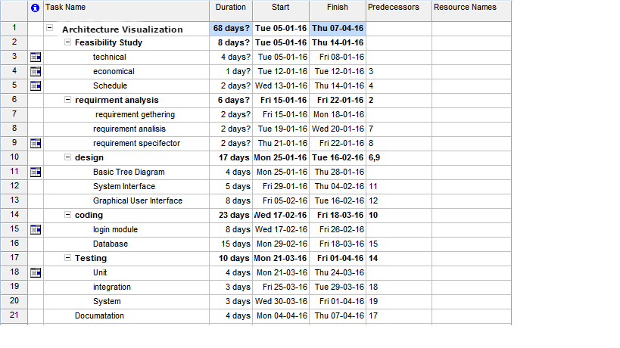

  - GANTT CHART REPRESENTATION

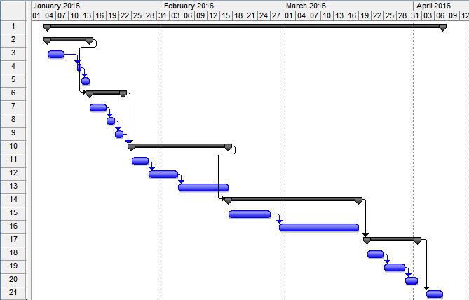

  - PERT CHART REPRESENTATION

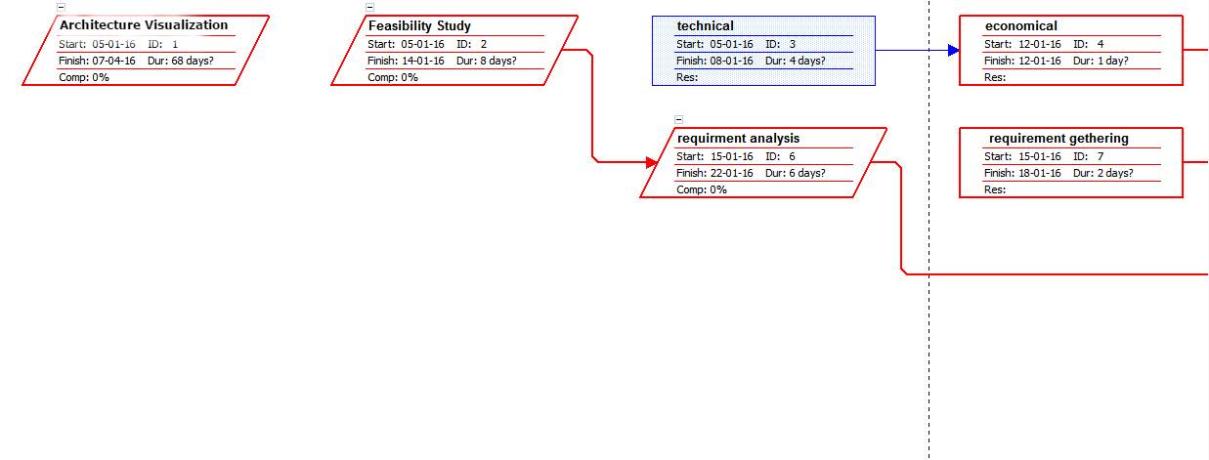
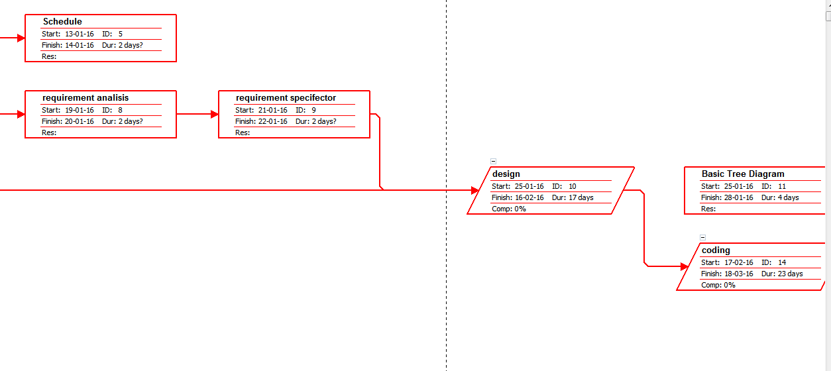

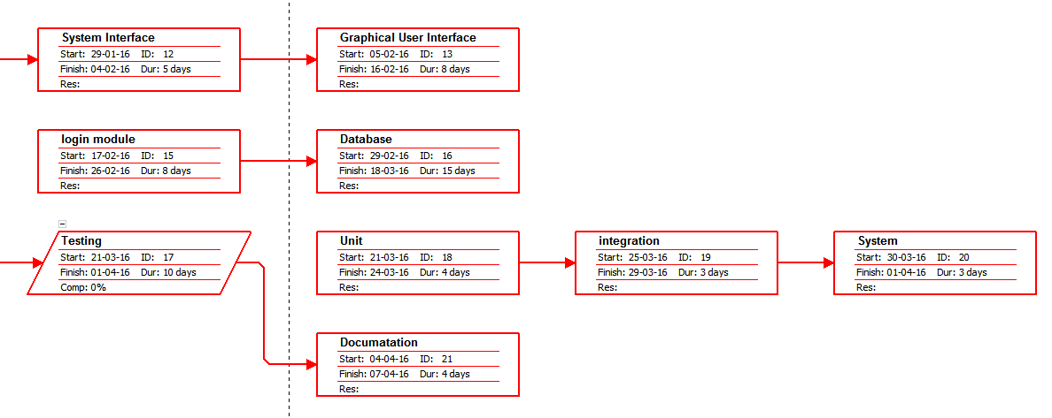

CHAPTER 6: PROJECT RESOURCES

  - PEOPLE

Developer | Roles and Responsibilities
14CE050 | Feasibility Study, analysis, coding, and designing.
14CE054 | Requirement gathering, Analysis, , coding, and testing
14CE059 | Feasibility Study, coding, designing and testing

User: Any user having basic knowledge of computer can use this software.

  - HARDWARE AND SOFTWARE

Hardware | Software
RAM:500 MB(2GB required by OS)  Hard Disk: 50 GB | Unity 5.5.1f1 (64-bit)  blender

CHAPTER 7: PROJECT TRACKING AND CONTROL
PLAN

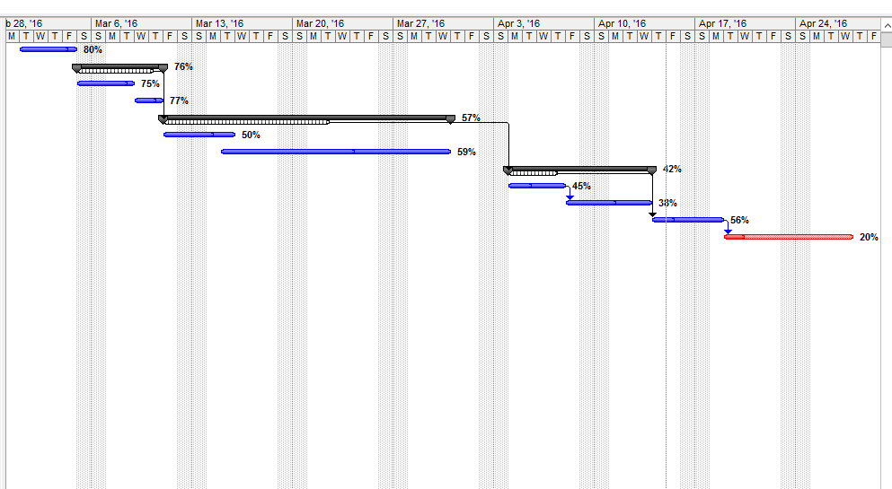

CHAPTER 8: SYSTEM DESIGN

  - SYSTEM APPLICATION DESIGN

    - Method Pseudo code

Module 1: Starting Activity

- This module is used to imort haar cascading xml sheet.

# multiple cascades: https://github.com/Itseez/opencv/tree/master/data/haarcascades

#https://github.com/Itseez/opencv/blob/master/data/haarcascades/haarcascade_frontalface_default.xml
face_cascade = cv2.CascadeClassifier('haarcascade_frontalface_default.xml')
#https://github.com/Itseez/opencv/blob/master/data/haarcascades/haarcascade_eye.xml
eye_cascade = cv2.CascadeClassifier('haarcascade_eye.xml')

Module 2: Video capture

- This module is used to capture video of user using webcame.

cap = cv2.VideoCapture(0)

Module 3: Image frame

- This module is used to exract the image frame from captured video.
ret, img = cap.read()
gray = cv2.cvtColor(img, cv2.COLOR_BGR2GRAY)
faces = face_cascade.detectMultiScale(gray, 1.3, 5)

Module 4: Detect face and eye
- This module is used to recognized face and eye from image frame.
faces = face_cascade.detectMultiScale(gray, 1.3, 5)
eyes = eye_cascade.detectMultiScale(roi_gray).

CHAPTER 9: IMPLEMENTATION PLANNING

9.1 IMPLEMENTATION ENVIRONMENT (Single vs Multiuser, GUI vs Non GUI)

- The implementation environment is single user and has user friendly GUI in IDLE python editor.

9.2 PROGRAM /MODULES SPECIFICATION

- In this project, we haven’t used one database.

  - CODING STANDARD

- Class names have first letter in capital case.
Example: Computer_Engineering.
- Variable names are in lower case.
Example: img.
- Method names are in mixed case with first letter in lower case.
Example: cv2.cvtColor(img,cv2.color_bgr2gray)
- Name of packages are in lower case.
Example: import cv2
- Avoid extraneous whitespace immediately inside parentheses, brackets or braces.
Example: spam(ham[1], {eggs: 2})
CHAPTER 10: TESTING

10.1 TESTING PLAN

- We have used Black box testing for the project.

- 2 TEST SUITE DESIGN

    - Test Cases

- Start Webcame

Test Suites No: 1
Test Suite Detail: open application

Test Case ID | Function Name | Test Case (Condition) | Expected Results | Actual Result | Pass / Fail
1 | Start Webcame | Test if webcam start without any error. | Webcame must start and able to detect images of user. | Webcame  running | Pass
 | Start Webcame | Test if webcam start without any error. | Webcame must start and able to detect images of user. | Error Occurs | Fail

- Recognize Face

Test Suites No: 2
Test Suite Detail: detect from image frame

Test Case ID | Function Name | Test Case (Condition) | Expected Results | Actual Result | Pass / Fail
1 | Recognize face | Test if system is able to detect face from image frame correctly. | System must  successfully detect face of user from image freame. | Face of user is detected. | Pass
 | Recognize face | Test if system is able to detect face from image frame correctly. | System must  successfully detect face of user from image freame. | User is not recognized. | Fail

- Saving detected image

Test Suites No: 3
Test Suite Detail: detected image details
Test Case ID | Function Name | Test Case (Condition) | Expected Results | Actual Result | Pass / Fail
1 | Saving detected image | Test if system is able to saving detected image successfully. | Detected image saved in current folder. | Image saved. | Pass
 | Saving detected image | Test if system is able to saving detected image successfully. | Detected image saved in current folder. | Error Occurs | Fail

CHAPTER 11: LIMITATION AND FUTURE ENHANCEMENT

- Limitation:
- It is unable to detect the face when there is low amount of light.
- It needs certain amount of brightness to recognize face perfectly.
- Medium GUI.

- Future Enhancement:
- Better GUI.
      - Add feature like it will first capture the certain pictures of the user and save it to the database with its specific id or name
      - Also when same detected again then it will show its id or name.

CHAPTER 12: CONCLUSION AND DISCUSSION

  - SELF ANALYSIS OF PROJECT VIABILITIES
- This application can use by any user which have certain knowledge about python. Also this system uses the latest technologies like OpenCV, Python, XML. So it was easy enough to develop the project. If any changes in the system are to be made, then they can be done very easily.

  - PROBLEM ENCOUNTERED AND POSSIBLE SOLUTIONS
- Problem that we face is unable to detect the face when there is a less amount of light so better to capture image in brightness, gather all materials and provide better GUI.

  - SUMMARY OF PROJECT WORK
- Face detection system is designed to provide different standard face database consisting a range of different face images varying in facial expression, lightening effect, presence and absence of accessories.
- Next generation person recognition systems will need to recognize people in real-time and in much less constrained situations.
- Face detection system is applicable to detect face of user and save it into current folder.

